1.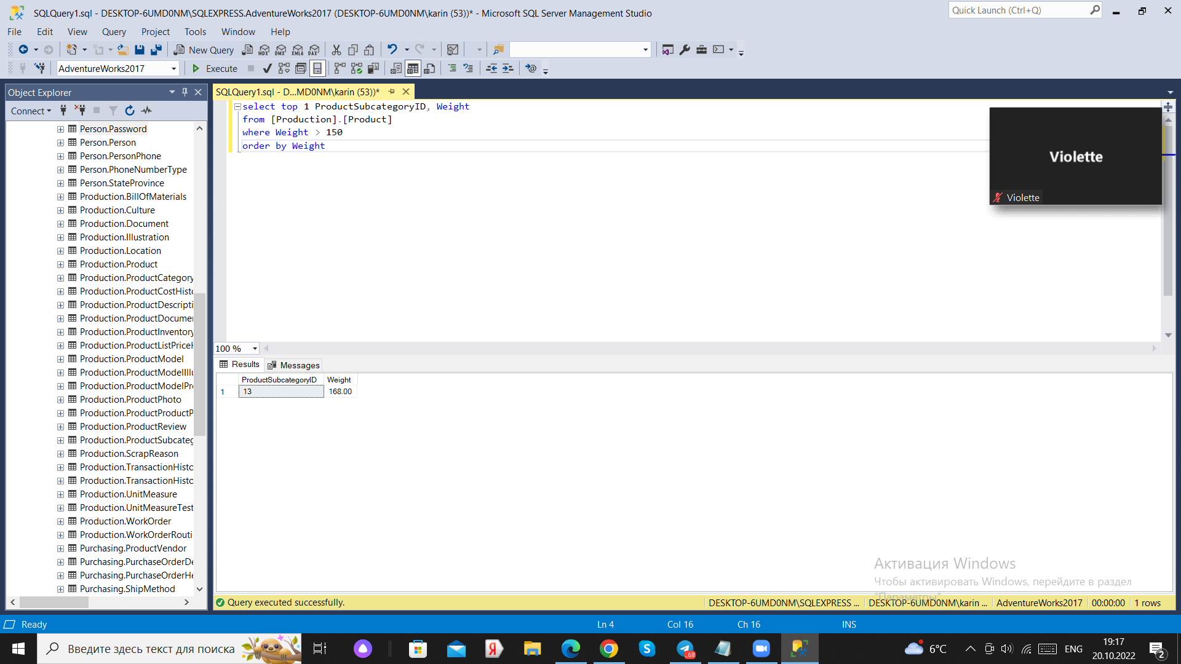

2.

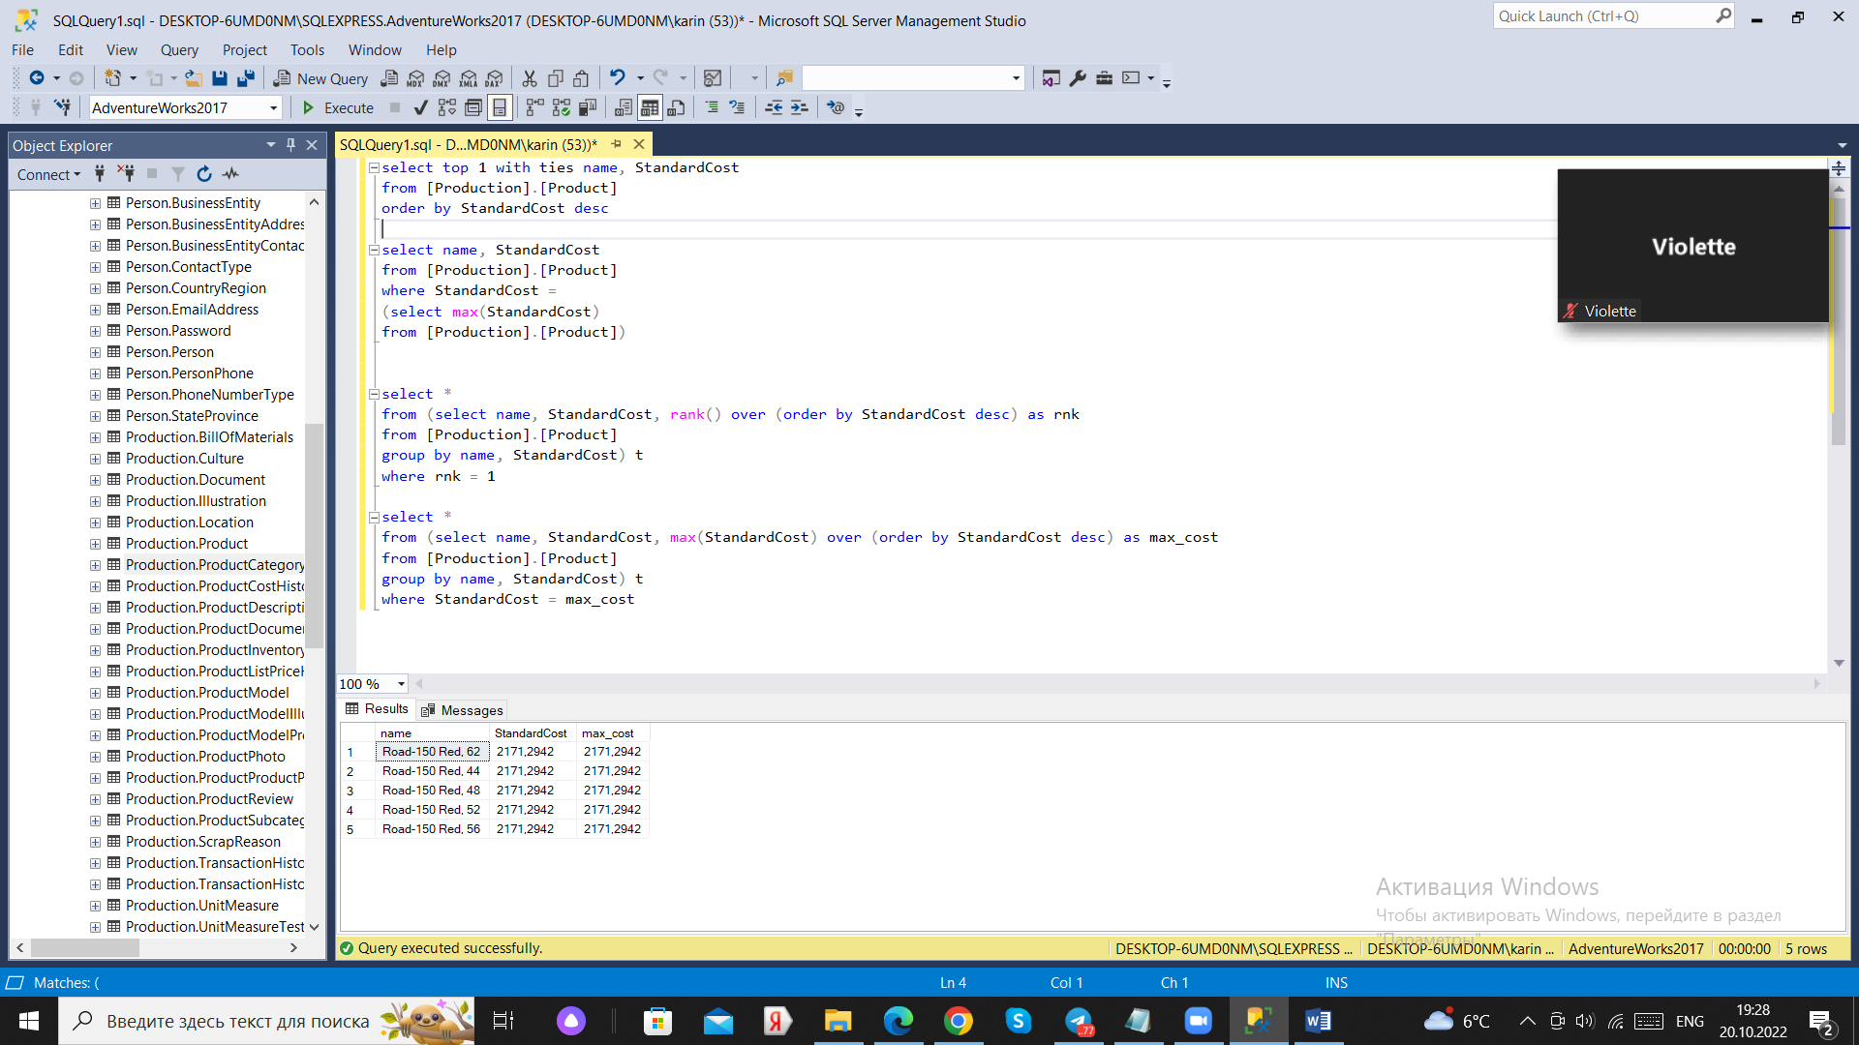

3.

select id_store

from store_dim

exept

select id_store

from sale_fct

4.

select p1.name, p1.last_name, p2.cnt

from seller_dim p1

left join

(select sellerID, count(productID) as cnt

from sale_fct

where detediff(year, date, getdate()) =<15

group by sellerID ) p2

on p1. sellerID = p2. sellerID

5.

Select p1. Id, p2. category

(From Users

Where email = ‘lex@gmail.com’) p1

join

(Select user_id, category, count (id) as cnt

From Notifications

Where is_read = false

Group by user_id, category) p2

On p1.id=p2. user_id